Words Matter Art Pieces
Trevor Neal
Description: I was tasked with assisting Artist Mark Yurkiw in creating 3D scans of two of his art pieces, Yearning to Breathe Free, and Re-Birth of a Nation. The scans were modified to create miniatures of the art pieces to raise funding for the @#1 Main St. Galley Inc. a 501c3 non-profit raising awareness for local artist to local people. Yearning to Breathe Free will be sold at fundraisers and venues for the homeless as thank you gifts at certain donor amounts. Re-Birth of a Nation will be sold for fund raising events for children’s cancer research. I took the high-resolution scans using the Creaform Go!SCAN Spark 3D Scanner and modified the raw scans in Creaform’s VXelements program. For other modifications, I used Microsoft 3D builder, for example, the spokes on the Statue were too thin, so I used 3D builder to extrude the spokes. Originally, I 3D printed the prototype models on our Prusa MK3S and Ultimaker S5 printers, once I saw the quality of the prints, I determined that we should use SLA printing for a higher, more detailed resolution. We used the Formlabs 3+ and the Elegoo Mars 2 Pro for these demo prints.
Equipment/Software Used:
- Creaform Go!SCAN Spark 3D Scanner
- Creaform VXelements
- Microsoft 3D Builder
- Prusa MK3S
- Ultimaker S5
- PLA
- Elegoo Mars 2 Pro
- ABS Mint Resin
- Formlabs 3+
- White Resin
Step by step of how to create it:
- The original art pieces to be scanned
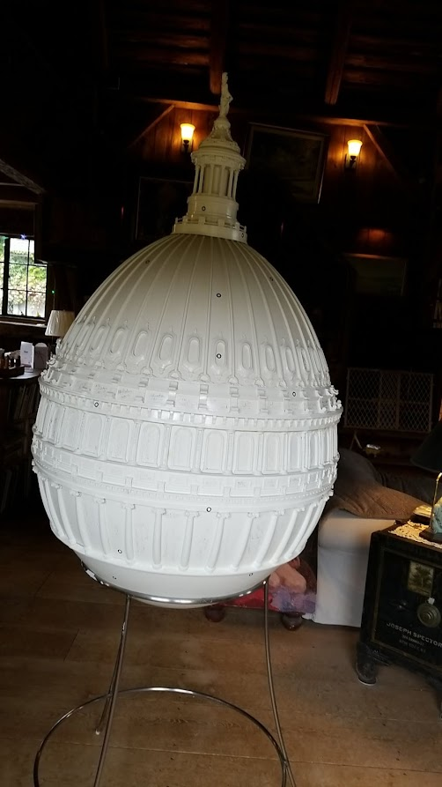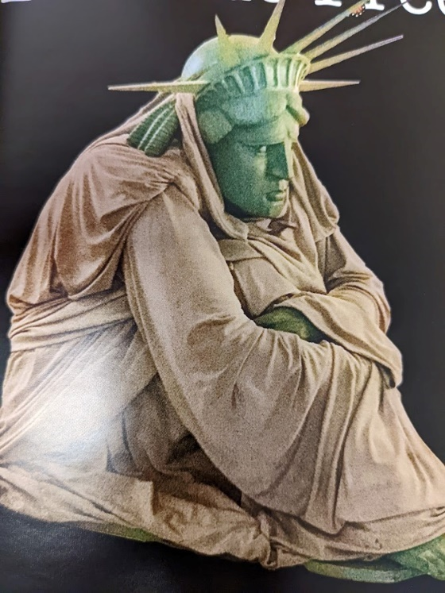
Re-Birth of a Nation Yearning to Breathe Free

- 3D Scanned the two art pieces with the Creaform Go!SCAN and edited the models in VXelements
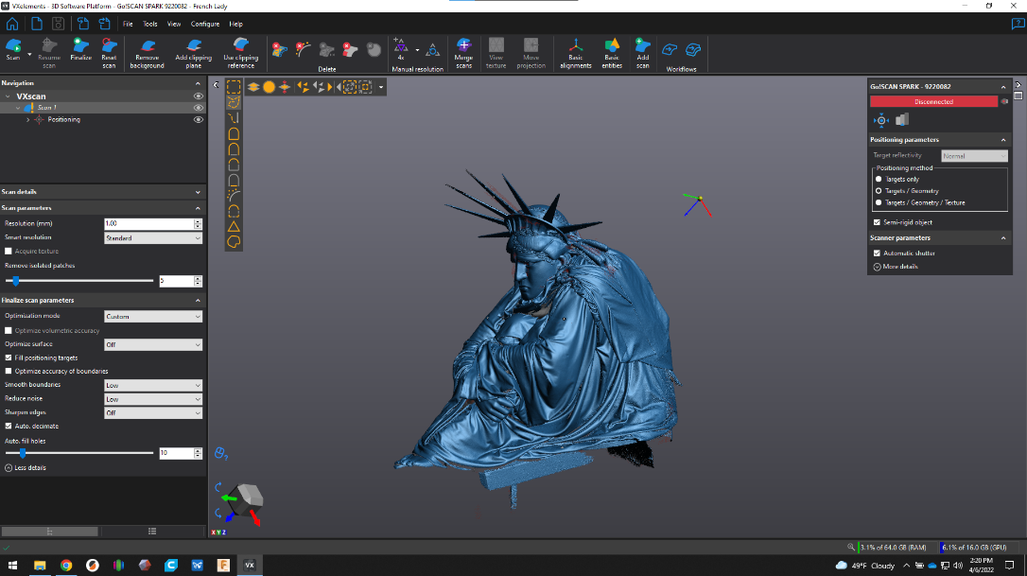

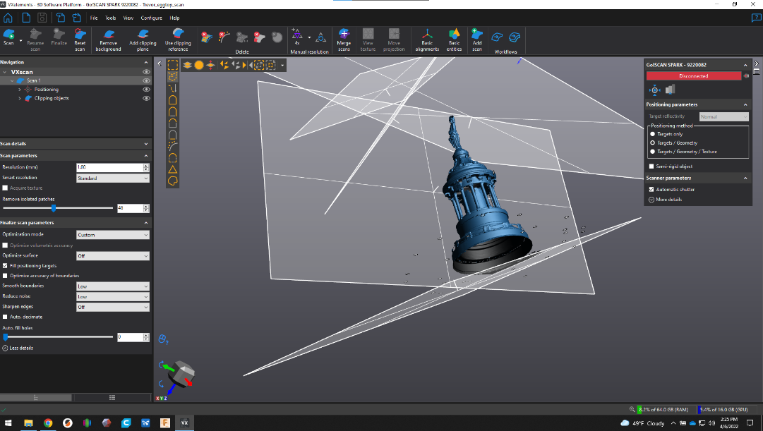

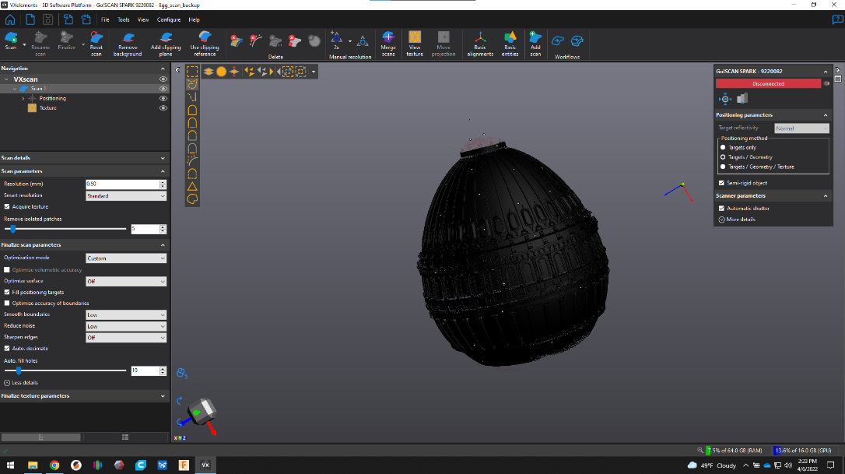

- Re-Birth of a Nation in Prusa Slicer
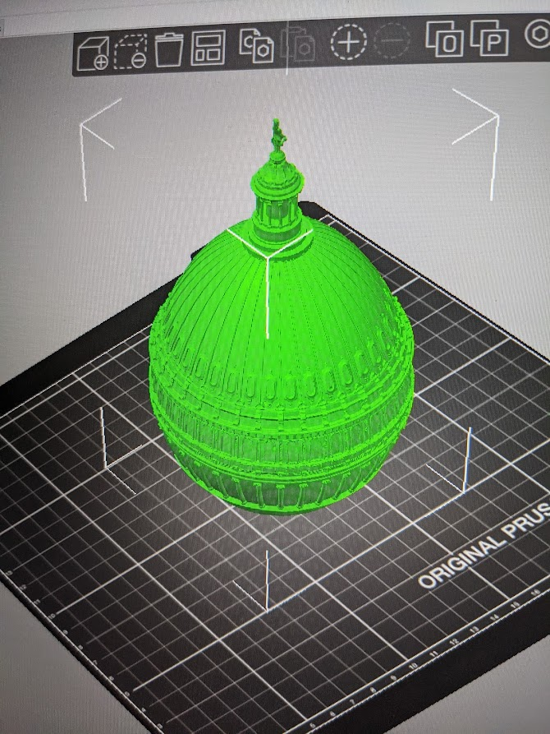
- 3D printed using FDM technology, lower detail
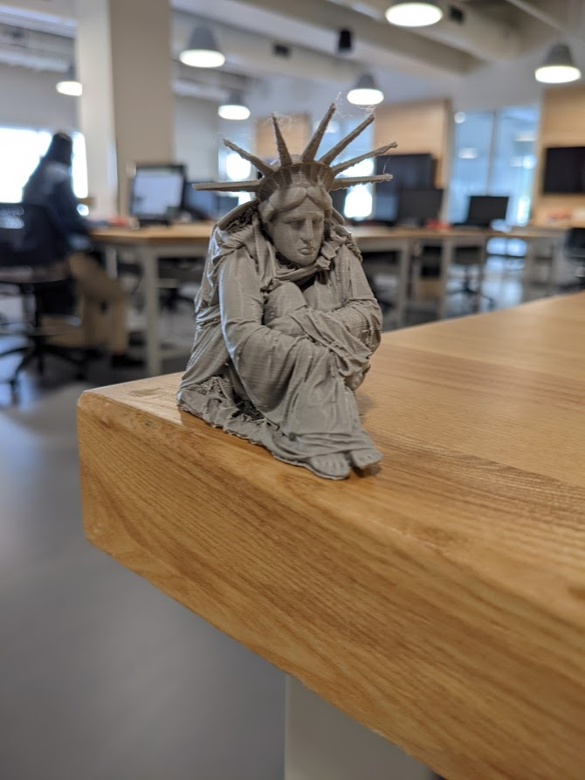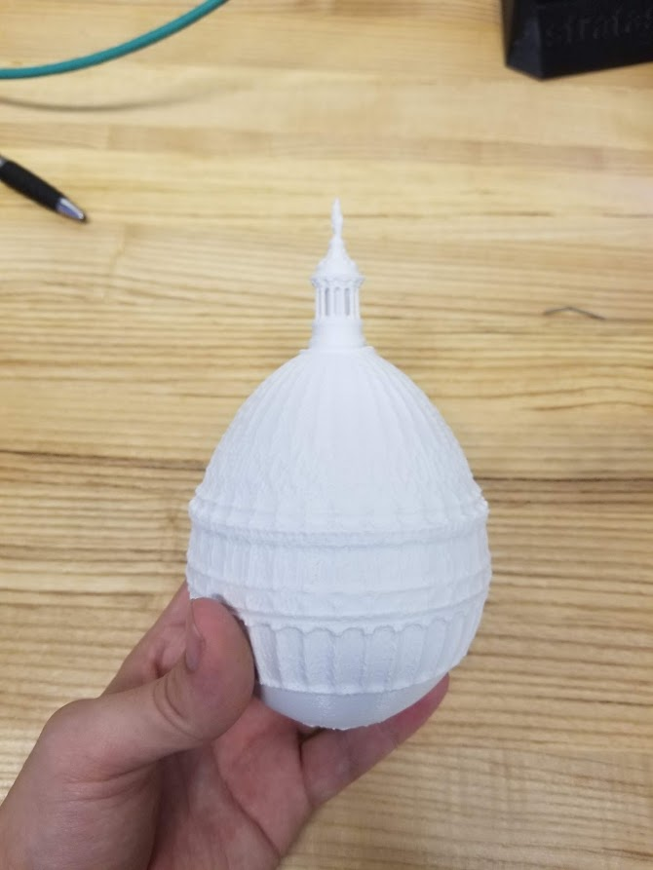
- 3D Printed using SLA technology on Elegoo Mars 2 Pro, higher detail
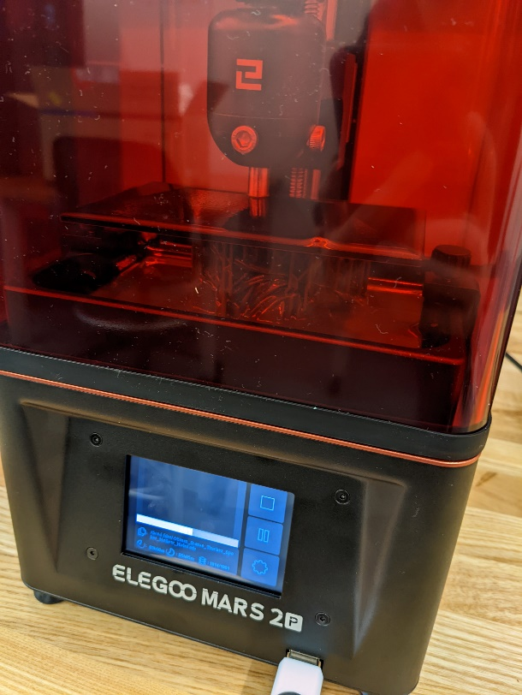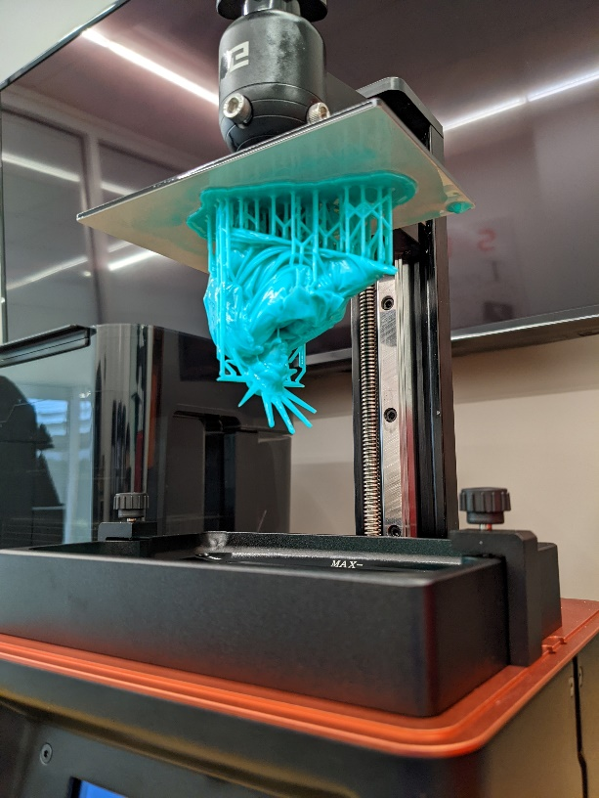
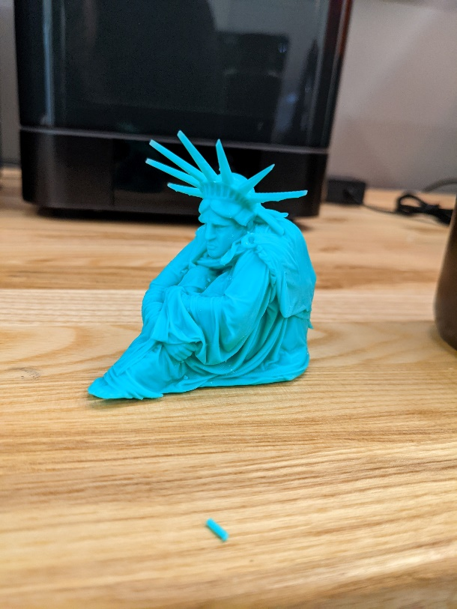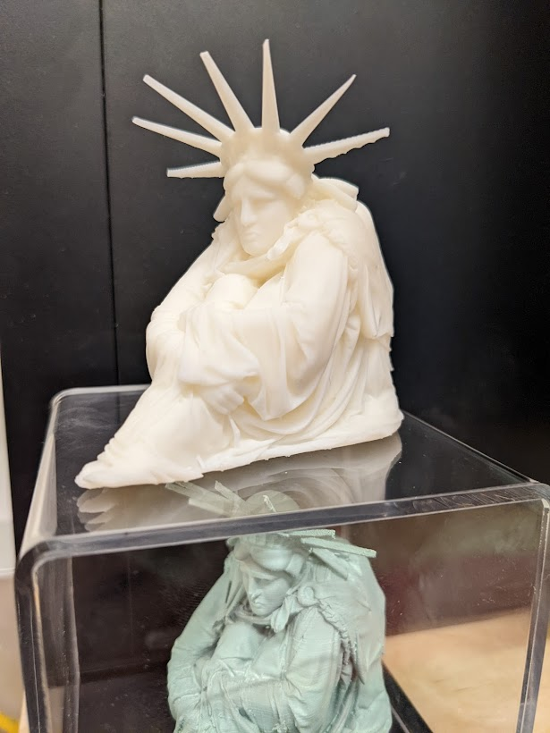
What was Challenging: During this project, the most challenging aspects were learning how to use SLA 3D Printing technology and learning to use the VXelements program to successfully scan objects in 3D.
What I Learned: Through the months working on this project, I learned the process of creating resin printing and understood what goes into creating a successful 3D scan, fully ready to be 3D printable.

